Life Science

🌱 Definition
# Source: AI Source: Provided by: [Data Path: Persons Table -> ID Column: 1, Name_En Column: Motasem Essam] -> From: [ChatGPT] on [5/27/2026]
Life science is the branch of natural science that studies living organisms and life processes. It focuses on how living things function, grow, reproduce, evolve, and interact with each other and their environment.
Life science includes the scientific study of:
- Humans
- Animals
- Plants
- Microorganisms
- Cells and ecosystems
In contrast to physical science, which studies non-living matter and energy, life science studies living systems and biological processes.

🧬 Main Branches of Life Science

1. Biology
# Source: AI Source: Provided by: [Data Path: Persons Table -> ID Column: 1, Name_En Column: Motasem Essam] -> From: [ChatGPT] on [5/27/2026]
- Focus: The general study of living organisms.
- Key topics:
  - Cells
  - Genetics
  - Evolution
  - Reproduction
  - Ecology
- Example question: How do living organisms grow and survive?

2. Zoology
# Source: AI Source: Provided by: [Data Path: Persons Table -> ID Column: 1, Name_En Column: Motasem Essam] -> From: [ChatGPT] on [5/27/2026]
- Focus: The study of animals.
- Key topics:
  - Animal behavior
  - Classification of animals
  - Animal anatomy and physiology
- Example question: How do mammals adapt to their environments?

3. Botany
# Source: AI Source: Provided by: [Data Path: Persons Table -> ID Column: 1, Name_En Column: Motasem Essam] -> From: [ChatGPT] on [5/27/2026]
- Focus: The study of plants.
- Key topics:
  - Plant growth
  - Photosynthesis
  - Plant diseases
  - Plant reproduction
- Example question: How do plants produce food?
Photosynthesis is commonly represented by:
$$6CO_{2}+6H_{2}O+light→C_{6}H_{12}O_{6}+6O_{2}$$

4. Microbiology
# Source: AI Source: Provided by: [Data Path: Persons Table -> ID Column: 1, Name_En Column: Motasem Essam] -> From: [ChatGPT] on [5/27/2026]
- Focus: The study of microorganisms such as bacteria, viruses, fungi, and protozoa.
- Key topics:
  - Infectious diseases
  - Microscopes
  - Microbial genetics
- Example question: How do bacteria reproduce?

5. Genetics
# Source: AI Source: Provided by: [Data Path: Persons Table -> ID Column: 1, Name_En Column: Motasem Essam] -> From: [ChatGPT] on [5/27/2026]
- Focus: The study of genes, heredity, and variation in organisms.
- Key topics:
  - DNA
  - Inheritance
  - Mutations
  - Genetic engineering
- Example question: Why do children resemble their parents?

6. Ecology
# Source: AI Source: Provided by: [Data Path: Persons Table -> ID Column: 1, Name_En Column: Motasem Essam] -> From: [ChatGPT] on [5/27/2026]
- Focus: The relationships between organisms and their environment.
- Key topics:
  - Ecosystems
  - Food chains
  - Biodiversity
  - Climate effects
- Example question: How do living organisms depend on each other?

🔬 Related and Specialized Fields
# Source: AI Source: Provided by: [Data Path: Persons Table -> ID Column: 1, Name_En Column: Motasem Essam] -> From: [ChatGPT] on [5/27/2026]
Life science connects with many other sciences, creating interdisciplinary fields such as:
- Biochemistry — chemistry of living organisms
- Biophysics — physics applied to biological systems
- Biotechnology — using living systems to develop products
- Molecular Biology — study of molecules inside cells
- Neuroscience — study of the nervous system and brain
- Environmental Science — interactions between organisms and the environment

🧪 Scientific Methods Used in Life Science
# Source: AI Source: Provided by: [Data Path: Persons Table -> ID Column: 1, Name_En Column: Motasem Essam] -> From: [ChatGPT] on [5/27/2026]
- Observation — studying living organisms and behaviors
- Hypothesis — proposing explanations
- Experimentation — testing ideas in laboratories or field studies
- Data Collection & Analysis — interpreting biological data
- Conclusion & Theory Development — building scientific understanding

📏 Importance of Life Science
# Source: AI Source: Provided by: [Data Path: Persons Table -> ID Column: 1, Name_En Column: Motasem Essam] -> From: [ChatGPT] on [5/27/2026]
Life science is important because it:
- Explains how living organisms function
- Improves medicine and healthcare
- Helps develop vaccines and treatments
- Supports agriculture and food production
- Protects ecosystems and biodiversity
- Advances biotechnology and genetics

⚡ Examples in Daily Life
# Source: AI Source: Provided by: [Data Path: Persons Table -> ID Column: 1, Name_En Column: Motasem Essam] -> From: [ChatGPT] on [5/27/2026]
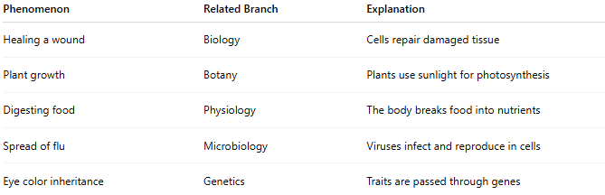
Phenomenon | Related Branch | Explanation
Healing a wound | Biology | Cells repair damaged tissue
Plant growth | Botany | Plants use sunlight for photosynthesis
Digesting food | Physiology | The body breaks food into nutrients
Spread of flu | Microbiology | Viruses infect and reproduce in cells
Eye color inheritance | Genetics | Traits are passed through genes

👩‍🔬 Famous Scientists in Life Science
# Source: AI Source: Provided by: [Data Path: Persons Table -> ID Column: 1, Name_En Column: Motasem Essam] -> From: [ChatGPT] on [5/27/2026]
- Charles Darwin — Theory of evolution
- Gregor Mendel — Laws of inheritance
- Louis Pasteur — Germ theory and vaccines
- Rosalind Franklin — DNA structure research
- Carl Linnaeus — Classification of organisms

🧭 Summary
# Source: AI Source: Provided by: [Data Path: Persons Table -> ID Column: 1, Name_En Column: Motasem Essam] -> From: [ChatGPT] on [5/27/2026]
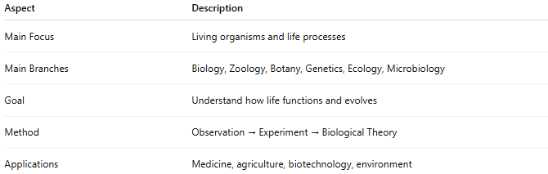
Aspect | Description
Main Focus | Living organisms and life processes
Main Branches | Biology, Zoology, Botany, Genetics, Ecology, Microbiology
Goal | Understand how life functions and evolves
Method | Observation → Experiment → Biological Theory
Applications | Medicine, agriculture, biotechnology, environment

